U3A Knox Wanderers Newsletter September 2020

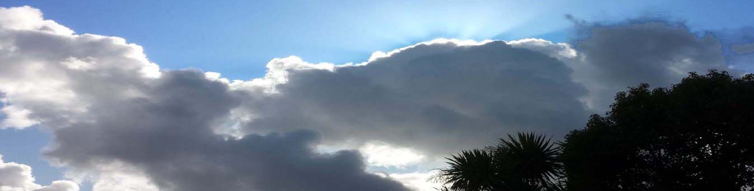
______________________________________________________________________________

Silver linings on clouds and spring in the air;
The basic truths will always be there.

Life does go on and if we can still see positives, or better still create some, then all will be well. Part of this is giving ourselves hope by planning for the future. It may not eventuate, and it may have to change, but I think it’s worth planning.

So, with this in mind, I have contacted the leaders whose 2020 offered rallies had to be cancelled, to draw up a tentative timetable for 2021. Very kindly they all said yes as did a couple of extras, so that we have a full complement for 2021. I will not publish them as a program until I have more details of venue, date, prices etc. Thank you to all those people. So far, this is what we have:

Draft Program for 2021
February: Lorraine and Heidi at Kilcunda
March: Imi and Dieter at Paynesville
April: Trudi and Neville at Shepparton
May: Di and Sal at Mildura
July Lunch: Mavis and Ray
August: Anne and Bob at Maryborough
September: Robyn and Brian at Lakes Entrance
October: Inge and Uli at Kyabram
November: Jan and Doug at Wodonga.
December Breakup: Doris and Charlie.

It may well be that caravan parks fill up very quickly, meaning that they are not willing to hold sites indefinitely, so I will email you as soon as I have details and we will just have to fit in with requirements.

My other plan is a Christmas get-together in December this year. Indoor venues are not likely to be able to accommodate us and every single club or society in greater Melbourne will be looking at outdoor celebrations. I have therefore chosen 2 picnic grounds which I will suss out as soon as I’m allowed. Both are quite secluded and not so well known. They have shade and toilets but I think no barbeques, which may mean fewer people. I suggest 10am rather than lunch time to beat potential crowds and maybe heat. Everybody will bring absolutely everything themselves, including chairs, tables and own food. This means last minute changes will not be too difficult. The date I am asking you to note in your diaries is Friday 4th December at 10am. I am making it early in the month, so that if the weather is prohibitive, a last-minute postponement is possible. The 2 picnic grounds are the Valley Picnic Ground and the Eagles Nest Picnic Ground, both in Olinda. We can just nibble our way through the morning or stay for lunch, but I think the earlier time is wise. If we sit apart, in separate small groups, the total number shouldn’t matter.

AGM
We are in the fortunate position of not being legally bound to hold an AGM and I cannot see a problem with our not holding one this year. The main task is to plan next year’s program. I can also report that our princely sum of $397.80 is resting peacefully in the Bendigo Bank. There have been neither fee deductions nor interest credits. If anyone had anything else to discuss, it will have to be via email.

Hoping, hoping, hoping to meet up again soon,

Brigitte

