U3A Wanderers April 2019 Newsletter.
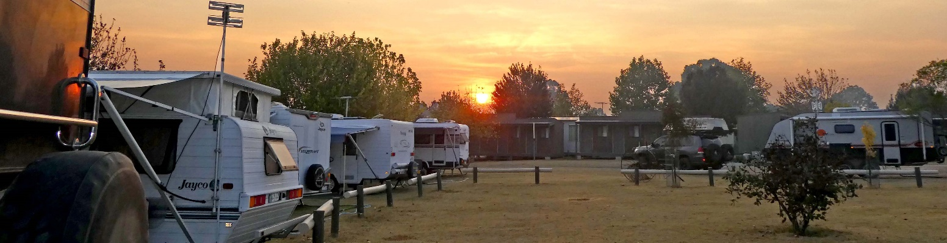
Hello all,

Another month gone and that makes it a quarter of the year as winter approaches. Did you need a reminder?

There is no rally this month. We were unable to fit one in due to holidays, Easter and Anzac Day. Hopefully these will provide you with enough entertainment.

The date for the July lunch has been set for Friday 19th July at 12noon at the Dorset Gardens Hotel. This is the last week of the u3a holidays so it won’t clash with classes. Thank you very much to Robyn and Brian Nelson for organising it. It will be pay as you order at the counter. I will publish it on the website as soon as Robyn and Brian are ready to take bookings but meanwhile please note the date in your diaries. This is one of only 2 opportunities apart from the rallies we have per year to get together and meet.

This month we welcome another new member: Caroline McKenzie. Welcome Caroline.

There are 2 corrections to the phone list. Please make your own adjustments.
Charlie’s and Doris’ surname was misspelt. It should be Eynaud not Eynard.
Quentin and Denise Ogle’s phone number should read 0411 189 231.

At the Mansfield rally a few people asked for the recipe for my macaroni muffins so here it is:
Maccaroni Muffins (adapted from Coles Magazine)
Ingredients :
¼ cup dried breadcrumbs
1 ¾ cups maccaroni
3 middle bacon rashers chopped
1 small brown onion chopped
100g feta crumbled
¼ cup sun dried tomatoes chopped
25g butter
½ cup milk
200g grated tasty cheese
2 eggs slightly beaten
Chicken stock powder to taste.
Method.
Cook macaroni till very soft and cool 10mins. Place in bowl.
Fry onion and bacon till golden and add to bowl. Add feta and SD tomato.
Melt butter in saucepan, add flour and stir till it bubbles. Gradually add milk stirring till it thickens.
Add to pasta mixture.
Stir in chees and eggs and chicken stock powder.
Sprinkle the breadcrumbs over the greased muffin holes, shaking out excess.
Divide equally in mini muffin tray. (makes about 40 – 50)
Bake in 170 C for 25 – 30 mins until golden and just firm to touch.

Our next rally will be at Swan Hill from the 16th to 20th May and we ask you to book through the website on www.u3aknoxwcc.weebly.com as soon as possible. This applies to all rallies as sometimes they do fill up and certainly caravan park managers get anxious when we ask them to hold sites without firm bookings. If they do get firm bookings, we cannot expect them to hold our tentative reservations. Thank you to Trudi and Neville Murray for all the work they’ve already put in.

Enjoy whatever you’re doing to fill in your time and remember Bertrand Russell’s quote:
“Time you enjoy wasting is not time wasted”.

Brigitte.

