U3A Wanderers January 2019 Newsletter.
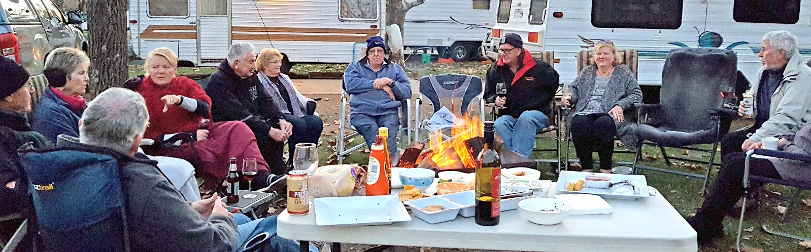
Hello all,

This is to introduce myself as your new co-ordinator and notify you of some unavoidable changes to the communication process as a result of Quentin’s retiring. I ask for your patience while I am learning. My aim is certainly to keep everything as it was as far as possible.

My details: Brigitte Salwat
Email: jbsalwat2@bigpond.com
Mobile: 0423814354

As most of you are aware, the old website has been closed and the new one can be accessed as before under wcc@u3aknox.org.au or via the u3aknox homepage: www.u3aknox.org.au . This new website is no longer password protected and also will no longer display rallies before 2018. It has necessarily had to be simplified a little.

The main reason for a newsletter at this time is the fast approaching Ballarat Rally from the 15th to 18th February. Because this is still a busy period for caravan parks, the managers have told us that they can no longer hold the requested sites for us without firm confirmation and deposits. This is really always the case but not usually a problem if the caravan park is not busy. There is therefore some urgency now for all potential participants to book as quickly as possible.

Newsletters will be sent through the u3a emailing system, so you may notice some changes in format.

That’s it for today. Hope to see you soon,

Brigitte.

