U3A Wanderers May 2019 Newsletter.
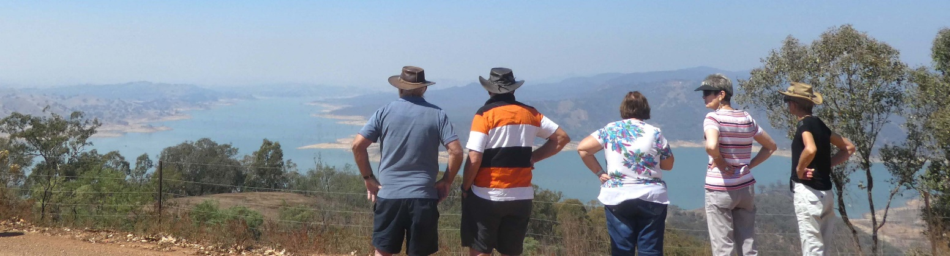
Hello all,

Just a short newsletter this time, but there are a couple of items worth reporting.

New member. We welcome new member Ilona Fajka. We hope to meet you soon Ilona.

The Swan Hill Rally is coming up soon. It is heavily booked, currently at 36 members so we can look forward to meeting a lot of friends again. We thank Trudy and Neville for all the preparation they have done. For those attending please check with Trudy to ensure your medical forms are up to date. You can download one from the website or Trudy will have a few spares. Remember in a big group it will be difficult for the rally organisers to chase you up.

The July Lunch. This will be held on Friday 19th July at 12 noon at the Dorset Gardens Hotel and details are on the website. We urge members to book as soon as possible. This is one of the very few opportunities we have to meet outside the rallies, so we look forward to seeing all those who haven’t hibernated for winter or fled up north.

RED ALERT: Port Fairy Rally. This rally has been postponed to February next year. There are several reasons which are perhaps not appropriately enumerated here, but please be assured that Lawrie and Alison have already put in considerable work to prepare this rally and would not wish a total cancellation. It could not easily be moved earlier because it is already only 2 weeks after Marysville and later would be getting too close to our many other end-of-year commitments. There will be no November rally but we will confidently be able to look forward to a great start for 2020.

Feel free to contact me at any time if you have any issues or information that you would like included in the newsletter. I will only publish one in June and July if there is information in worth disseminating. Most of what you need is on the website at www.u3aknoxwcc.weebly.com.

Cheers, Brigitte

