U3A Wanderers Newsletter August 2019
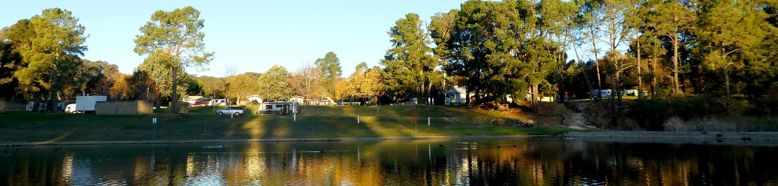
Hello once again,
It may have escaped your notice, but we are heading towards spring which means that our second semester program is upon us.
The next 2 rallies are to Warburton on the 15th – 19th August and to Inverloch on the 13th – 16th September. It is not too late to enrol for either. (Click on the links)
AGM on Tuesday 24th September at 3.30pm at Park Hills. We only have one opportunity per year to get together to discuss policy and organisation. I do not see myself as the sole decision-maker on behalf of all members, but unless issues are brought up and discussed on this occasion I am thrust into this position. We do not have a committee to represent you. It is also the occasion where we try to organise rally leaders for 2020. Consider volunteering. Remember: no organisers, no rallies.

Some matters I would like to see discussed are:
- The appointment of an assistant webmaster. At this stage I am enjoying doing it, so this consideration is not with any immediate view to a successor. I do not visualise any current role at all for this person because I think 2 people fiddling with the site could be confusing. What I want is just some-one who is willing to learn what is involved, so that if I were suddenly incapacitated, at least someone could teach a successor.
- Our link to the U3A website. If you have recently logged in to the U3A website, you will have noticed some changes. There is now a direct link to our website. Check it out and come prepared to comment if you wish.
- Rally guide-lines. Please look at these on our website and consider whether we want additions or alterations. Maybe we need to think about rally size and a policy for bringing visitors.

I will email a draft agenda early in September and meanwhile ask you all to put the date in your diaries and submit the attendance form on the website. Also please think of any issues you would like to add to the agenda and let me know.

I have been asked to start the Who’s Who page again with photos of group members. Because we often meet quite rarely, we forget names and faces. I plan to come around with my camera at future rallies and photograph participants in order to publish them together with names only. Please be prepared for this and let me know if you do not wish to be included. I am also happy to include a photo that you forward to me (couples together) if you are unable to attend rallies in the foreseeable future.

Cheers to all of you,
Brigitte

