U3A Wanderers November 2019 Newsletter.
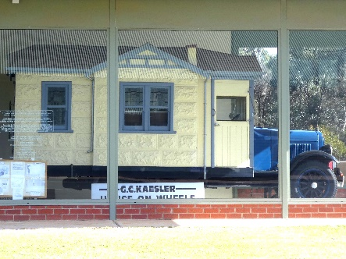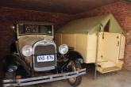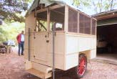
Hello all,

I saw both these caravans on my recent trip to the Barossa Valley. The first one is G. C. Kaessler’s House On Wheels, built in 1931. It took him and his family from his home in Nuriootpa through Broken Hill and Bourke to Brisbane and home again via Sydney, Canberra, Melbourne and Mt Gambier. The second one with the ingenious raisable roof was Hans Heysen’s, built in 1932. I thought they were so good I had to share them with to you. The construction has changed, the pleasure hasn’t.
Now to the newsletter. The Marysville rally is now behind us and with it our camping program for 2019. The report will be published when Margaret gets back from her holiday. Every one of the rallies as well as the July lunch was a resounding success with lots of fun, friendship and interesting experiences. We need to remind ourselves constantly to be grateful for the world that we live in, the opportunities that we have and the people who make it possible.
That brings me to: Our Christmas Break-up.
It will be held on Wednesday 11th December at 5 pm at the Parkhill campus. Dinner will be served at 6pm. Please check the website for details. The meal will be catered for so BOOKINGS ARE ESSENTIAL, again through the website. Cost is $10 pp.
SOME HELPERS ARE NEEDED. We need a few people to bring either a salad or dessert. If you can help please ring Georgina on 0407 311 434.
2020 Rallies: I have been asked about details. The title page has been published but I cannot establish any links or give details until rally organisers give them to me. So I ask those who have volunteered for rallies in 2020 to let me know details as soon as you have them, preferably using the form for rally organisers on the website. We still need organisers for August. I know you weren’t all able to be at the AGM where most of the rallies were decided, so here is your chance to please consider volunteering.
Maryborough 2020. Anne and Bob Power have booked the Maryborough rally for April and details are on the website. There are very few dates available to us in April so we have chosen to do it on the Anzac Day weekend. This means that caravan park managers are particularly anxious that they get a deposit. Remember, we temporarily book sites and cabins but cannot expect them to hold these if they get other bookings. This one is pet friendly, even including 3 cabins! So even though it’s early and our heads are full of other commitments, please make room in your brain for Maryborough.
I wish you all a wonderful Christmas break and lots of renewed enthusiasm for 2020. I’d like to finish with:
A huge hurrah for the organisers of rallies and functions!!!
Brigitte

